Mack Hall

1/25/19

ECE 342 - Blue 1 | AC Bluetooth Switch

Prof. Shuman

Interface & Property Definition Table

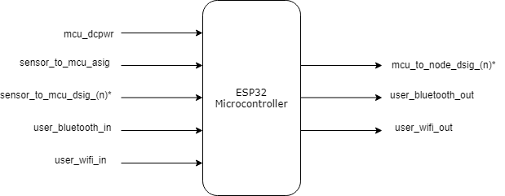

**Fig. 1.** Black Box Diagram of ESP32 Microcontroller Block

**Table 1.** ESP32 Microcontroller Block Interfaces and Properties

|  |  |
| --- | --- |
| Interface | Properties |
| mcu_dcpwr | VNominal: 3.3VDC:  VMax: 3.6VDC  VMin: 2.3VDC  IMin: 500 mA |
| sensor_to_mcu_asig | VMax: 6 VDC  VNominalLow: 0.36 VDC  VNominalHigh: 5 VDC  VMin: -0.5 VDC |
| sensor_to_mcu_dsig_(n)* | VHighMin: 0.75*mcu_dcpwr VDC VHighMax: VDD + 0.3 VDC  VLowMin: -0.3 VDC  VLowMax: 0.25*mcu_dcpwr VDC |
| user_bluetooth_in | Must be able to enable/disable relays  Must be able to set a time up to 60 min.  Must be able to give commands from over 20 ft  Interface must be via a mobile phone (Android) |
| user_wifi_in | Must be able to enable/disable relays  Must be able to set a time up to 60 min.  Must be able to give commands from over 20 ft  Interface must be via a mobile phone (Android) |
| mcu_to_node_dsig_(n)* | Disables output after 1 hr. if timer enabled  Operates output channels independently  IMax: 1.2A  IMin: 0A |
| user_bluetooth_out | Must be able to report on current/voltage draw  Must be able to report data to phone 20 ft away  Must be able to confirm length of timers  Must be able to disable channels if timer is up |
| user_wifi_out | Must be able to report on current/voltage draw  Must be able to report data to phone 20 ft away  Must be able to confirm length of timers  Must be able to disable channels if timer is up |

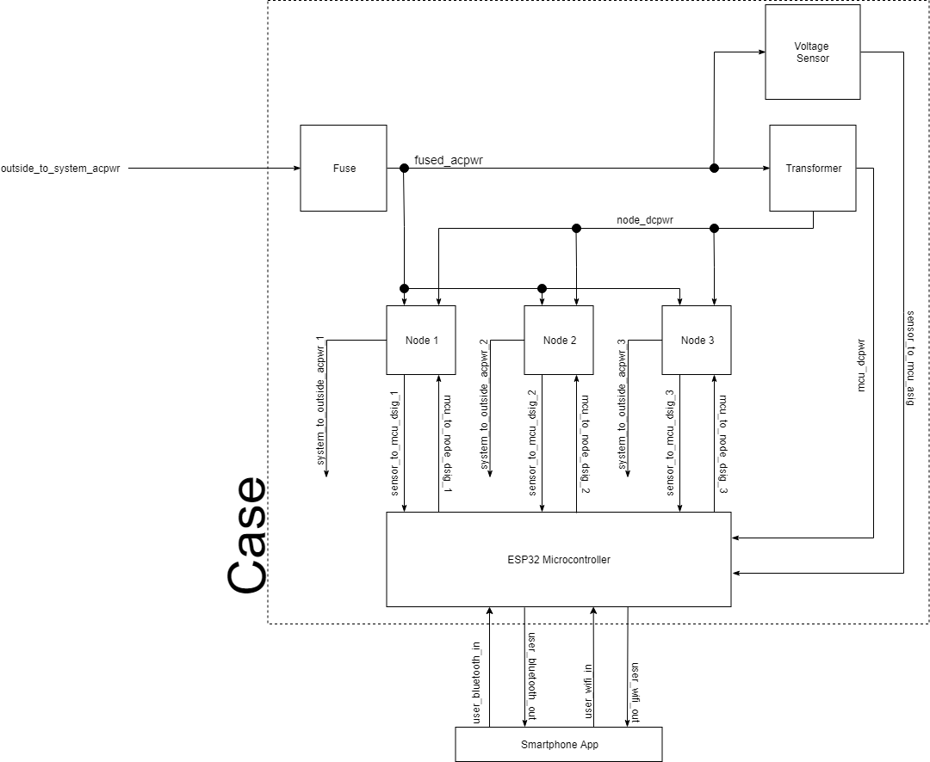

**Fig. 2.** High Level Box Diagram of AC Bluetooth Switch

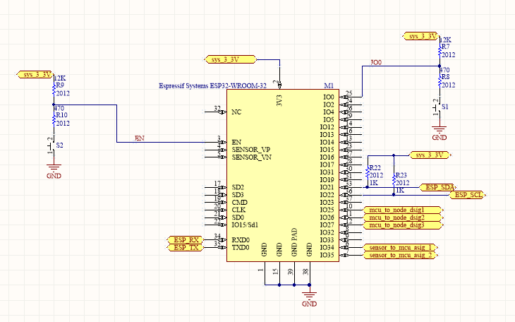

**Fig. 3.** Schematic of ESP32 Microcontroller Block in Custom PCB

**Fig. 4.** Schematic of Custom PCB**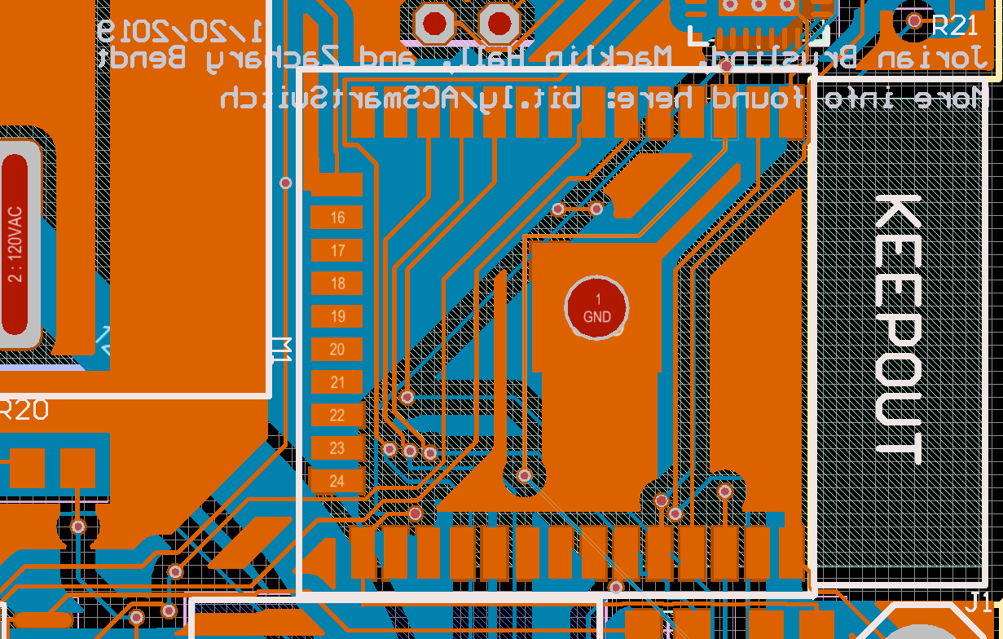Fig. 5.** Closeup of Schematic of ESP32 Microcontroller Slot on Custom PCB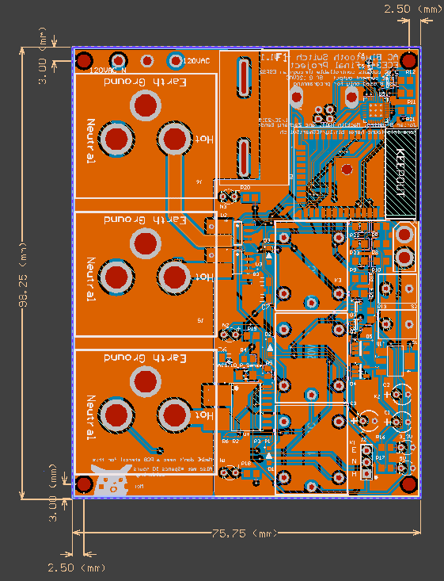

NOTE: The KEEPOUT section has no traces running through it, as to avoid interference with the bluetooth and WiFi signals the microcontroller is sending and receiving.

**Fig. 6.** Custom Code written to the ESP32 Microcontroller